Assignment 1
Exercise 1 PHP Basic
Ex1
<?php
echo "Welcome to PHP!";
?>

Ex2
<?php
echo "Hello ";
echo "World!";
?>

Ex3
<?php
echo "<h2>This is a heading</h2>";
echo "<p>This is a paragraph.</p>";
?>

Ex4
<?php
$name = "Your Name";
echo "My name is $name.";
?>
Ex5
<?php
$a = 10;
$b = 20;
echo "Sum: " . ($a + $b);
?>

Ex.6
<?php
$first = "Open";
$second = "Source";
echo $first . " " . $second . " Technology";
?>

Ex7
<?php
echo 'This is single-quoted text.<br>';
echo "This is double-quoted text.";
?>
Ex8
<?php
echo "Line 1<br>";
echo "Line 2<br>";
echo "Line 3<br>";
?>
Ex.9
<?php
echo "He said: \"PHP is easy!\"";
?>

Ex10
<?php
print "This is printed using print statement.";
?>
#Output
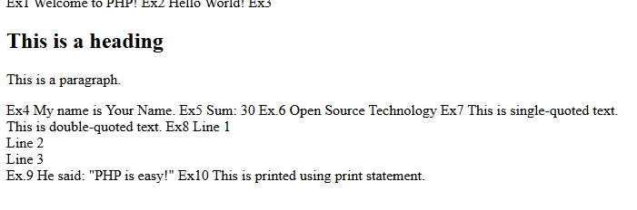

#Exercise Operators and Expression
<?php
echo "<h3>Arithmetic Operators</h3>";

$a = 10;
$b = 3;

echo "a + b = " . ($a + $b) . "<br>";
echo "a - b = " . ($a - $b) . "<br>";
echo "a * b = " . ($a * $b) . "<br>";
echo "a / b = " . ($a / $b) . "<br>";
echo "a % b = " . ($a % $b) . "<br>";
echo "a ** b = " . ($a ** $b) . "<br><br>";

echo "<h3>Assignment Operators</h3>";

$x = 5;

echo "Initial x = $x<br>";

$x += 3;
echo "x += 3 → $x<br>";

$x -= 2;
echo "x -= 2 → $x<br>";

$x *= 2;
echo "x *= 2 → $x<br>";

$x /= 3;
echo "x /= 3 → $x<br>";

$x %= 3;
echo "x %= 3 → $x<br><br>";

echo "<h3>Comparison Operators</h3>";

$p = 10;
$q = "10";

echo "p == q : ";
var_dump($p == $q);

echo "<br>p === q : ";
var_dump($p === $q);

echo "<br>p != q : ";
var_dump($p != $q);

echo "<br>p > 5 : ";
var_dump($p > 5);

echo "<br>p <= 10 : ";
var_dump($p <= 10);

?>

#Output
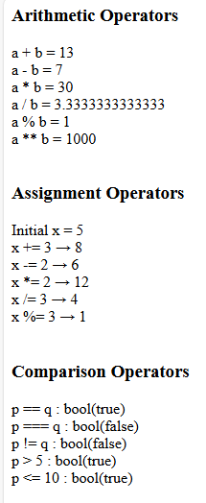

#Exercise Form
<?php
echo '
<html>
<head>
<title>Simple Form</title>
<style>
.center {
width: 250px;
margin: 100px auto;
text-align: center;
}
input {
margin: 5px;
padding: 5px;
}
</style>
</head>

<body>

<div class="center">
<h3>Student Form</h3>

<label>Name:</label><br>
<input type="text" id="username"><br>

<label>Roll No:</label><br>
<input type="text" id="rollno"><br>

<button onclick="displayOutput()">Submit</button>
</div>

<script>
function displayOutput() {
let name = document.getElementById("username").value;
let roll = document.getElementById("rollno").value;

document.write("Name: " + name + "<br>");
document.write("Roll No: " + roll);
}
</script>

</body>
</html>
';
?>
#Output
